# Internet of Things Test 2

In a project team who is responsible for writing the programming code?

A. Engineer

B. Project Manager

C. Developer

D. Marketing and Communications

ANSWER: C

Who in the project management team is responsible for promoting the product?

A. Engineer

B. Project Manager

C. Developer

D. Marketing and Communications

ANSWER: D

What is the name for the set of rules which govern data communication?

A. Virus

B. Encryption

C. Protocol

D. Firewall

ANSWER: C

What is the overall term which is used to describe software which can damage the files on a computer?

A. Virus

B. Firewall

C. Malware

D. Worm

ANSWER: C

John has purchased a robo buggy which is controlled using a micro:bit. He doesn’t seem to have the required code blocks available in make:code. What is the problem?

A. He has purchased the wrong version of hardware for his micro:bit

B. He hasn’t added the necessary package into make:code

C. It isn’t compatible with his version of micro:bit

D. He should update his internet browser

ANSWER: B

What base number system is binary?

A. 1

B. 2

C. 4

D. 8

ANSWER: B

In ASCII the binary representation for ‘A’ is 10000001. What is the binary representation for ‘B’?

A. 10000001

B. 10000010

C. 10000011

D. 10000111

ANSWER: B

On the following bitmap image what would be the binary representation for the second row in the image if 1 is on and 0 is off?



A. 00000

B. 10101

C. 01010

D. 11111

ANSWER: B

When an image is stored it stores metadata as well as the actual image data. What is metadata?

A. Lots of data

B. A type of bitmap

C. The file type that an image is stored as

D. Data about data

ANSWER: D

When sampling a sound file to turn it into a digital file we have to say how many samples should be taken per second. Which unit of measurement is used?

A. Decibels

B. Hz

C. Seconds

D. Bits

ANSWER: B

Sam has sampled a sound file and found it to be poor quality. When resampling the file, what should she do to improve the quality?

A. Increase the sample rate

B. Decrease the sample rate

C. Compress the file

D. Use a better quality cable

ANSWER: A

On the micro:bit, what is the name of the device which transmits data wirelessly?

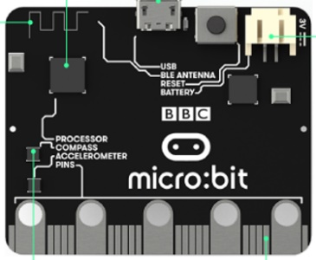

A. USB

B. BLE Antenna

C. Compass

D. Accelerometer

ANSWER: B

What is the name of the sensor which can be used to control a car in a racing game by tilting your phone?

A. Compass

B. Temperature

C. Tilt

D. Accelerometer

ANSWER: D

What will the program output if name = Gareth?

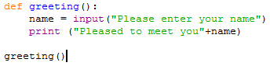

A. Pleased to meet you +Gareth

B. Pleased to meet you+name

C. Pleased to meet you Gareth

D. Pleased to meet youGareth

ANSWER: D

In the following list a linear search is being used to check if “St Helens” is in the list. How many items will need to be checked?

[“Bradford”,”Salford”,”St Helens”,”Warrington”,”Wigan”]

A. 1

B. 2

C. 3

D. 4

ANSWER: C

In the following list a binary search is being used to check if “St Helens” is in the list. How many items will need to be checked?

[“Bradford”,”Salford”,”St Helens”,”Warrington”,”Wigan”]

A. 1

B. 2

C. 3

D. 4

ANSWER: A

A large list is currently not in any order. To make searching quickly it needs to be put into order. Which of the following algorithms can do this?

A. Binary search

B. Sequential search

C. Bubble Sort

D. Binary Sort

ANSWER: C

Which of the following does not form part of the Internet of Things?

A. A fridge freezer with a camera in which can be checked from the supermarket

B. A power socket which can be controlled from a mobile telephone

C. A washing machine which can be turned on via a mobile phone from school

D. All of the above

ANSWER: D

Which of the following is a type of image?

A. DOCX

B. BMP

C. XLSX

D. All of the above

ANSWER: B

Which statement in Python will create an output on screen?

A: Print

B: print

C: Output

D: output

ANSWER: B